To All Incoming Seniors,

Summer assignments are due on the first day of school. If we are still having distance learning by then, you will email me all your work. If we have school, then you will bring it with you.

Over the summer, you will read the book The Kite Runner by Khaled Hosseini. You may either buy the book used on Amazon for as little as $3.81, or you can read the online version by clicking on the link below.
Here is the online version of The Kite Runner by Khaled Hosseini.
http://online.fliphtml5.com/kmfb/xrnv/#p=1

Over the summer you will read the entire book. Take the time to read, understand and enjoy it. It is important that you read the book rather than look up summaries or other online aids. Again, take the time to read even if it is difficult. Remember, we are preparing for college this year, and in college you will have to read texts that challenge you!
Assignments:
You will hand in the following assignments based upon the book. Please type your responses in 11-point font, 1.5 spacing, Times New Roman.

1. Research the custom of Kite Flying in Afghanistan. Find two articles online. For each article, please do the following:
A. Take notes. Please take substantial notes about this custom so you can understand it when you read about it in the book.
B. Use easybib.com to generate a citation in MLA form. Each article needs a citation below your notes.

2. Amir says, on the first page of The Kite Runner, "...it's wrong what they say about the past, I've learned, how you can bury it. Because the past claws its way out."
In a 1 page response you will do the following:
A. Interpret what Amir is saying in your own words.
B. Relate the quote to the book and Amir's life.
C. Relate the quote to your own life. Explain how it relates to you.

3. At about the half-way mark in the book, write a 1 page Character Analysis: Choose one of the major characters: Amir, Hassan, Baba, Ali or Assef.
A. Describe the character.
B. Choose one part of the text that really highlights what kind of person this character is. Explain what happens in this part of the book and then explain how the scene shows the qualities of this character.
C. Explain one relationship this character has. Why is this relationship important? Describe the relationship. Use a part of the book (another part other than the one you used in B) as evidence for your analysis of the relationship.

4. Compare Hassan and Amir. How are they similar? How are they different? What accounts for these differences? Be specific and use the text as evidence. (1/2 -1 page)

5. This is a coming of age novel. This means that the main character, Amir, goes through a series of changes while growing up, and truly evolves as a person. He is a dynamic character. He changes! Please explain how Amir changes and evolves. Use 2 parts of the text to show this change. (1/2-1 page)

6. Why is the book called The Kite Runner. Who is the Kite Runner? Does this change from the beginning to the end? Explain in detail. (1/2 page)

7. What is your favorite part of the book? Explain why this part is important in the context of the entire book.

8. Draw a life map for Amir's life. Please have 15 moments from the book. For each moment, be sure to have a 1-2 sentence description and a picture. Amir's life map may look like any of the following models. These are just ideas of how your map can look.

BE SURE TO SEE THE LAST ASSIGNMENT BELOW AFTER THE LIFE MAP MODELS!!!
- 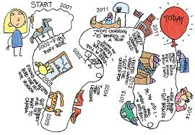

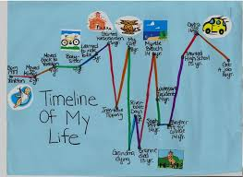
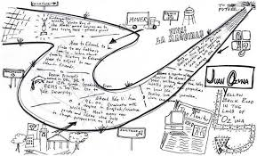

.

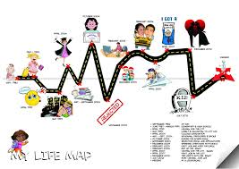

LAST ASSIGNMENT:
Draw a life map for your own life. Please have 15 important moments from birth to the present. Just like you did with Amir's life, for each moment you will have a 1-2 sentence description and a picture. You may draw this digitally if you don't want to draw it by hand.

